Unemployment Rate plot
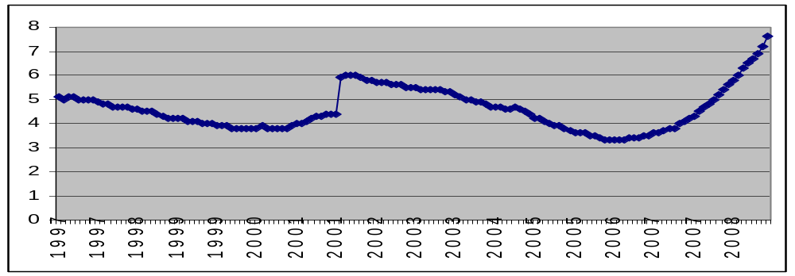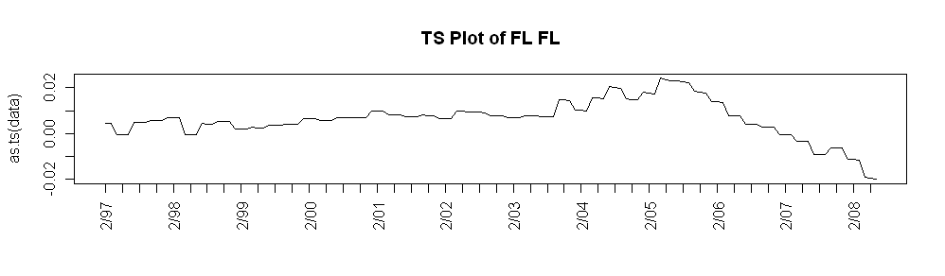
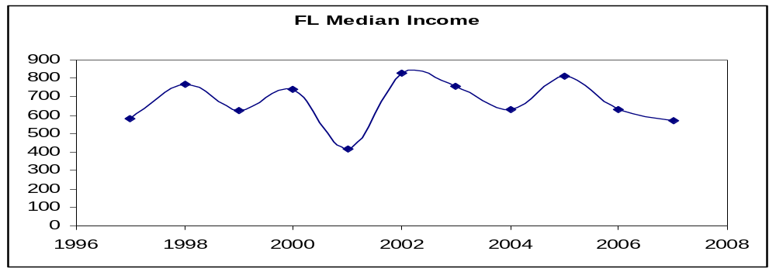

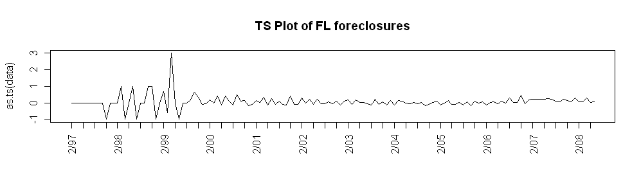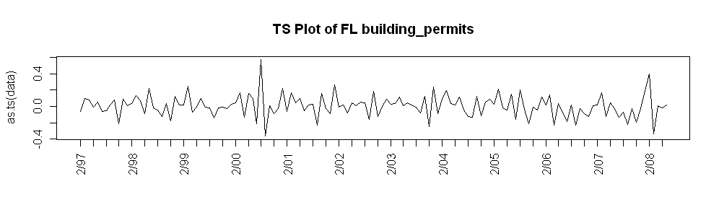
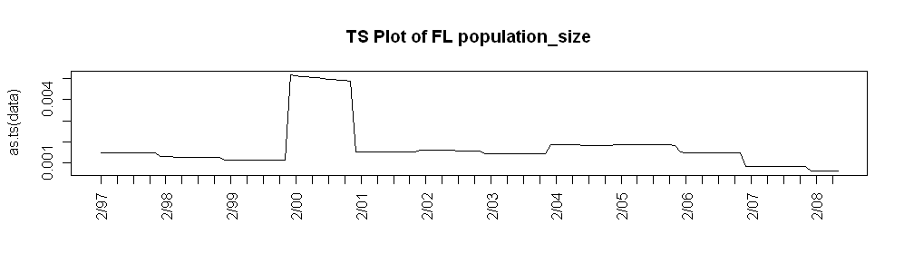
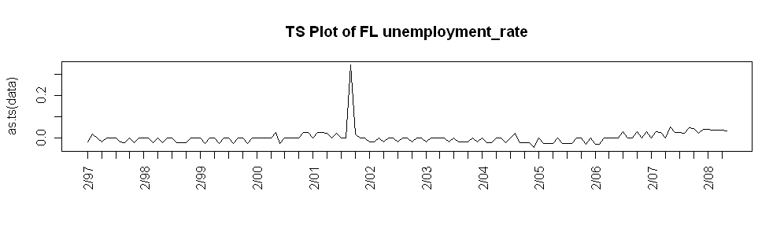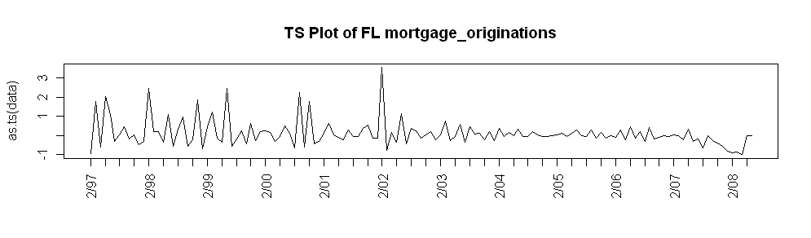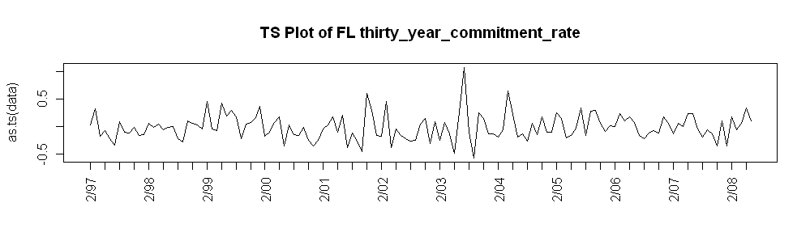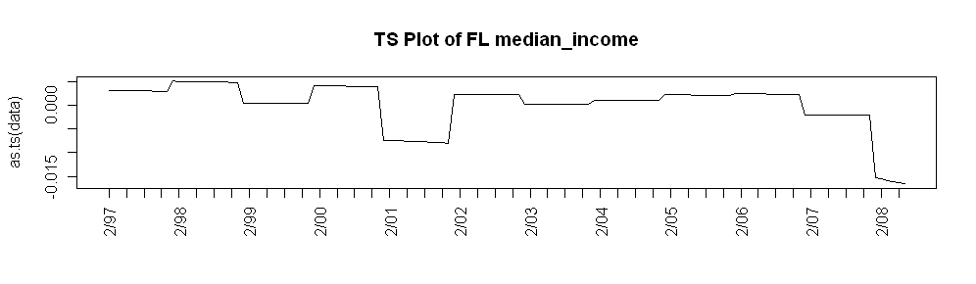
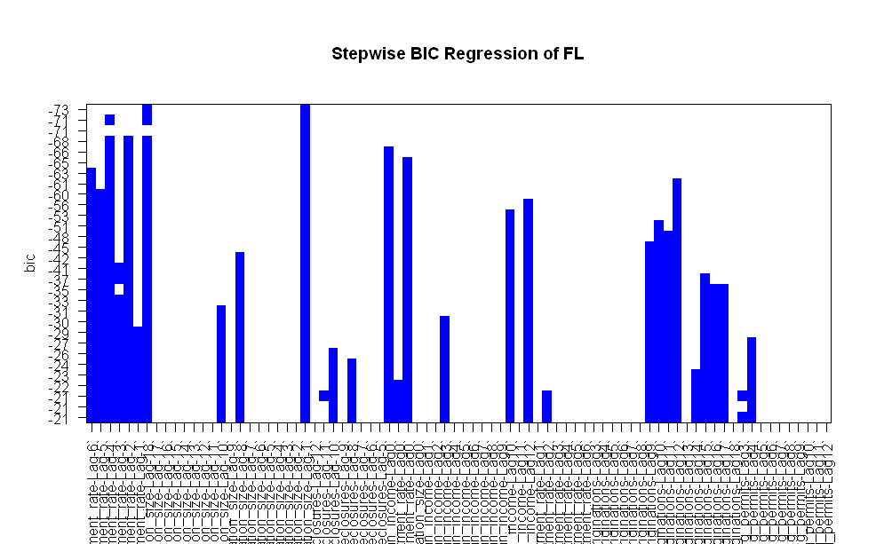

FL
Unemployment rate lags-6,-4,-2, 0
Population size lags -1, 0
Median income 0
Commitment rate 0
Mortgage originations 12
0 | 0 | 12 | -6#-4#-2#0 | -1,0 | 0 | 0

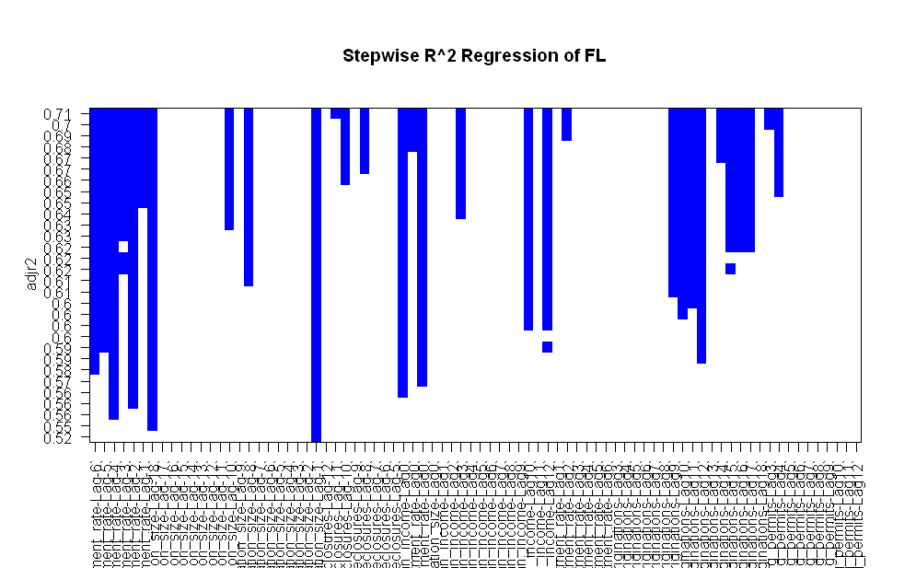

Foreclosures??? Gives high R_squared but high BIC as well

Florida Take 2

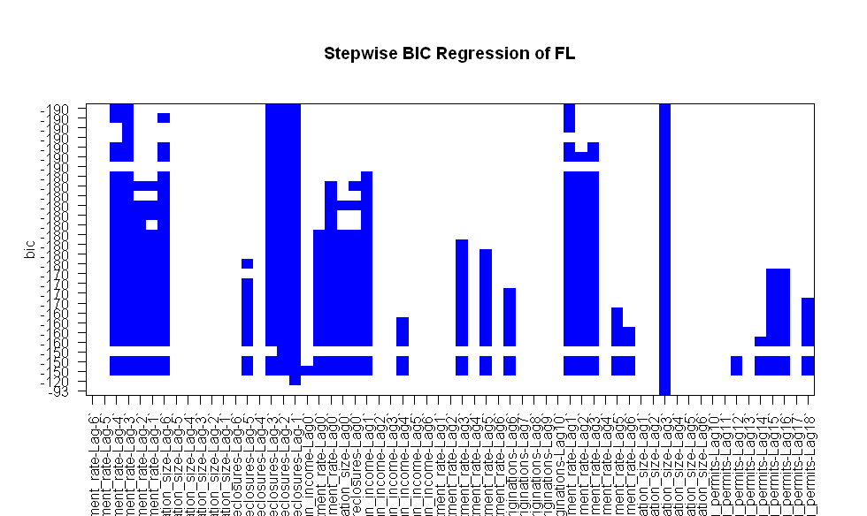

Unemployment rate lags -4,-3, 1, 3
Population size lags -6, 3
Foreclosures -3,-2,-1
=>
0 | 0 | 0 | -4#-3#1#3 | -6#3 | -3,-1 | 0

VA

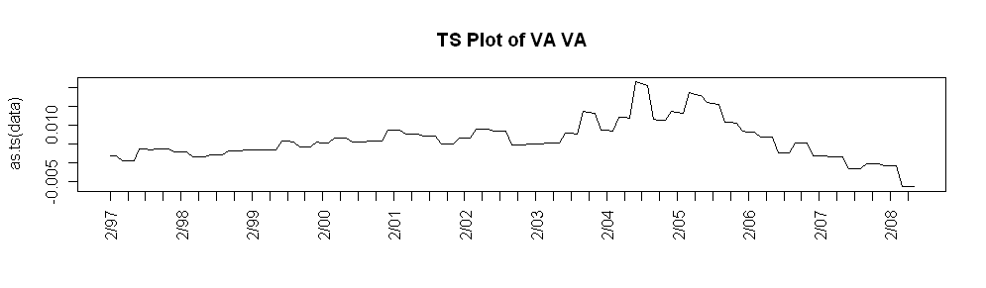
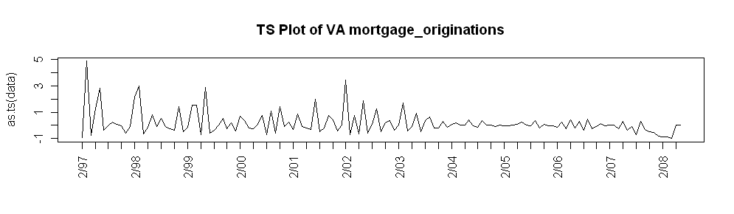

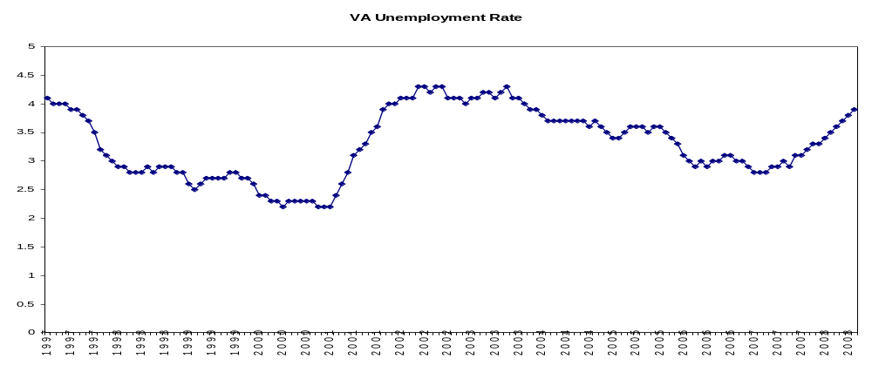

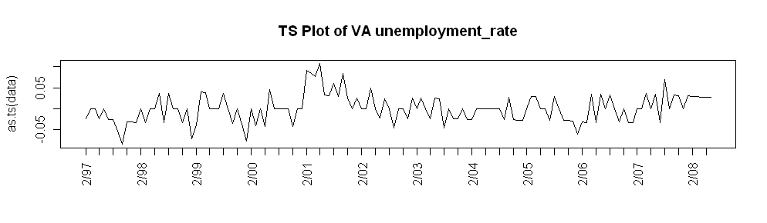
POP SIZE CHART
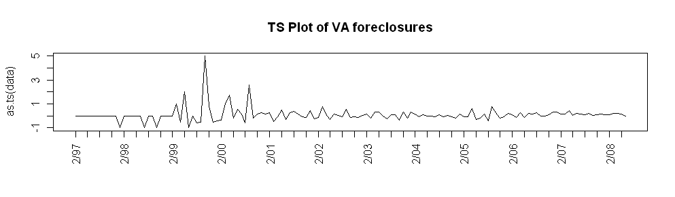
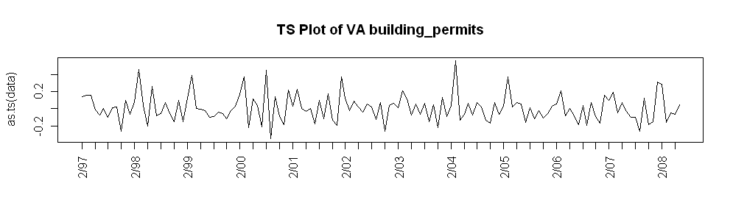

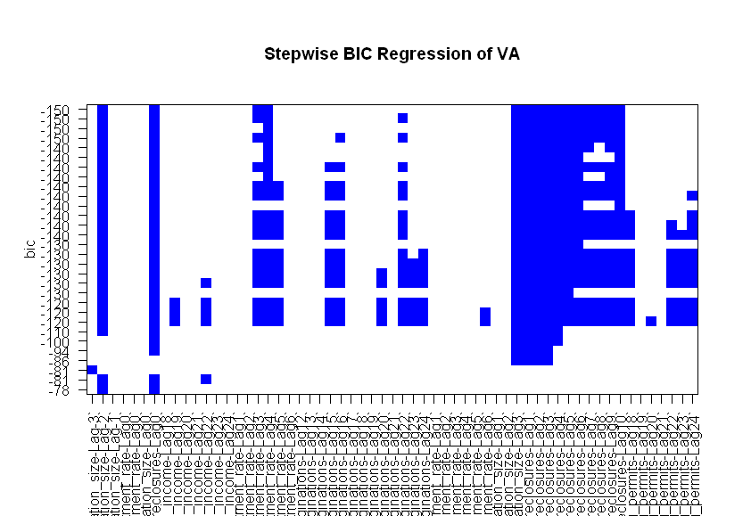

Initial:
18,24 | 0,6 | 12,24 | 0,6 | -3,3 | 0,10 | 18,24

Pop size -2,3
Foreclosures 0,1,2,3,4,5,6,7,8,9,10
Unemployment 3, 4
Mortgage originations 16, 22

